Communities build what they dream. Families get what they need. Children thrive.

AOK October Network Meeting Notes:

- Introductions/Check-In: What is your favorite Halloween candy?
- Upcoming Events:
  - October 13th
    - Community Home Partners Family Fun Day
    - 11am-130pm
    - For community children and their families who live in their homes. Bicycle giveaway, petting zoo, food, and more!
    - 655 Cascade Garden Drive, Rock Island
  - October 14th
    - WQPT PBS Imagination Station
    - 9am-2pm
    - Meet PBS characters, engage in hands on activities, and more! Register to attend online. Volunteers also needed!
    - https://wqpt.org/imaginationstation/
  - October 19th
    - Building Bridges, Creating Support – Virtual Parent Café
    - 630-730pm
    - Connect with other parents and caregivers in a safe, open space. Email Angelica @ avillarreal@birthtofiveil.com to register today!
  - October 21st
    - Floreciente Trunk or Treat
    - 1-3pm
    - The Floreciente Association is hosting this fun family event as a block party at 4th Ave & 7th St in Moline. Kids costume contest, games, candy and more!
  - October 23rd-27th
    - SAL Community Services & Hiney Heroes
    - Diaper Drive
    - Help end diaper need in our community! Drive through drop off at SAL office on October 23rd from 6am-6pm All sizes of diapers & pullups welcome. Size 4, 5, & 6 are in high demand! Open packages welcome as well.
  - October 26th
    - Fright Night in the Park
    - 5-7pm
    - Enjoy trick-or-treating, music, dancing, and a costume contest down at Schwiebert Riverfront Park in Rock Island.
- CAPAP: Data Conversation
  - Ending Phase 1:
    - The data workgroup will meet in October to review the Local Problem Snapshot. It will be shared to the network at the November AOK Network Meeting on November 1st
  - Data Conversation
    - The aims of the first data conversation are to connect the AOK Network to local child and family outcomes data, consider if the local Problem Snapshot data reflects the AOK Network community, and approve the Final Local Problem Snapshot
- AOK & Equity
  - AOK Equity Definition
    - Equity in AOK Networks is realized when all children and families have just treatment and opportunities, which includes valuing and embracing their unique cultures, identities, abilities, languages, needs, and preferences
  - Our Process
    - In an equitable early childhood system, we work toward equity by meaningfully including and involving families that are impacted by inequities in the creation of a system of services and supports that works with and for them
  - Our Impact
    - We achieve equity when one’s race, ethnicity, or social circumstance(1) does not determine how children and families’ fare; when every child and family have access to everything they need to thrive
      - (1) Social Circumstance: includes but is not limited to age, gender, sexual orientation, language, immigration status, place of origin, education, learning ability, income, disabilities, geographic location, housing arrangement, spiritual belief, and family background

- Unequal Opportunity Race Video

- Equity Discussion (small groups/breakout rooms – 20min discussion followed by 10min debrief)
  - What stood out most to you in the video? Why?
  - What inequities do you see in your work? Is your organization/community taking any efforts to address the inequity?
  - When considering the AOK Equity One-Pager, does your organization have similar goals/priorities?
  - What excites you about the one-pager? How can you see it aligning with you or your organizations efforts?
  - Jamboard link from online participants: https://jamboard.google.com/d/1iwoyC_-RBqYcRH3Swg0uUxhwb98lQdClJb7JtNLO0-U/viewer?ts=651d5e33
  - In-Person Network Debrief:
  - 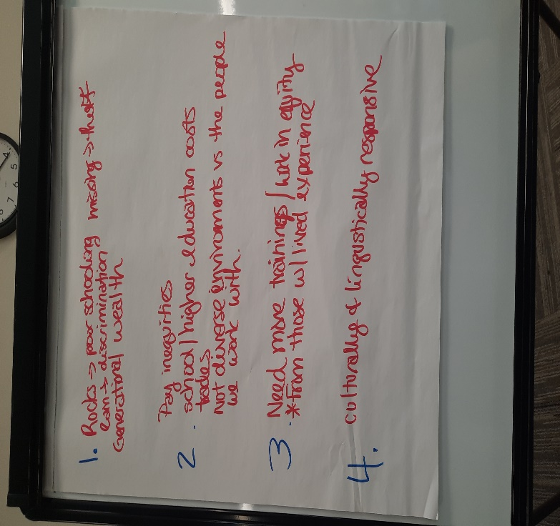
- Network & Partner Updates
  - AOK Network & Birth to Five
    - Virtual Parent Café
    - October 19th
    - 630-730pm
  - EveryChild
    - We have pillowcases to give to your clients who need them – variety of different designs and they were all handmade
- Partner Presentation – Abigail Pritchard: World Relief
  - World Relief Quad Cities
    - We provide services to refugees and immigrants in the Bi-State region
    - We seek to provide financial, emotional, cultural, and spiritual support to refugees – victims of war and persecution around the world – who are being placed in the QC
    - World Relief QC has been standing for the vulnerable for more than twenty years. World Relief QC began serving refugees in 1999 as a sub-office of World Relief Chicago. Since 1999, we have served over 3,000 refugees, immigrants, and secondary migrants in Rock Island County.
    - Expanding and getting an office in Scott County
  - Who is a refugee?
    - A refugee is someone who has fled their home country due to a demonstrated, credible fear of persecution on account of their race, religion, political opinion, national origin or social group
  - Who is an immigrant?
    - An immigrant is anyone who leaves their home country – the pace where they were born – and goes to live in another place
    - The term encompasses refugees, asylum seekers, migrants, asylees and more
  - Who is an asylee?
    - An asylum seeker is someone who arrives at the US border seeking refuge from violence and/or persecution, but their claim has not yet been approved as credible. The major difference between asylum seekers and refugees is that refugees have their status approved before they enter the US and asylum seekers make their claim once they arrive in the US
  - World relief is global and there are only ~25 in the US – with Moline, IL being one of them!
  - Youth Mentoring Program Goal:
    - At World Relief, our desire is to see these youth and families flourish and reach their fullest potential, despite the early obstacles they face upon immigrating. We work to facilitate the healthy integration of immigrant youth into life in the US by connecting youth and their parents, teachers, and administrators with early childhood programming, summer camps, multilingual academic support, mentorship, mental health resources, and other community integration opportunities.
    - The YMP’s goal is to provide concrete support in the context of safe relationships by helping the mentees create and meet goals that advance their desired life and purposes
  - Program Information
    - YMP is supported by federal funds via Refugee Social Services/RSS (grant for the state of Illinois, managed by the Jewish Federation (JFED) in Chicago, from the Federal Office of Refugee Resettlement (ORR))
    - Eligibility Requirements: Youth who entered the country with refugee status, APA or asylee status, or Special Immigrant Visa holder (SIV)
      - Between the ages of 15-24/25
      - Has been in the US 5 years or less
  - Program Overview
    - Time commitment: at least 1-2x/week. In person or virtually (via WhatsApp/FB messenger/facetime)
    - Help them create SMART goals and help them meet goals they’ve set (accountability, finding resources, “hand-over-hand”, encouragement)
    - Enter into into Track-It Forward
  - Integration Barriers: Perspectives from Refugee Youth
    - The biggest barriers refugees reported they face adjusting to life in America:
      - Language
      - Discrimination and bullying
      - Education
      - Cultural Adjustment
  - Refugee Youth Protective and Risk Factors:
    - Individual
      - Protective: Knowledge, access to resources, internal sources or strength (optimism)
      - Risk: poor health, mental health, substance abuse, poverty
    - Relationships
      - Protective: safe, supportive, nurturing contacts
      - Risk: type of relationship, trauma, violence, abuse
    - Community
      - Protective: concrete supports, social equity
      - Risk: housing, food, transportation, medical insecurities, geographic location and isolation
    - Social
      - Protective: laws and regulations, formal and informal concrete supports
      - Risk: discrimination, acculturation and adaptation challenges
  - Details of being a mentor
    - Meet as often as you both can (but preferably more than 1x/month)
    - Meet when you both can
    - Meet how you both can (WhatsApp, Messenger, FaceTime, at their house, outside, etc)
  - Sample Goals:
    - Enrolling in a school/training program
    - Graduating school/program
    - Getting/upgrading a job
    - Getting a permit/license
    - Saving money/getting a bank account
    - English – level gain (BHC)
    - Raising a letter grade in a class at semester
  - Common Issues with Mentees
    - Mentees not keeping set meetings
    - Mentees texting/calling at odd hours
    - Mentees asking for rides/money/help beyond the scope
  - Common Issues with Mentors
    - Mentors not recording hours
    - Mentors not recording enough detail in meeting notes
    - Mentors being unclear on reportable goals
  - Feeling stuck…
    - Learn their language
    - Play a game
    - Read a book/watch a movie and talk about it
    - Ask them about videos from where they lived before, or something else from their culture/life
    - 20+ questions
    - You can always end early and try again another day

