Communities build what they dream. Families get what they need. Children thrive.

November Network Meeting Notes:
- Introductions & Check-In Question: How would you describe your work to a child?
- CAPAP: Data Conversation
  - Ending Phase 1:
    - The data workgroup met in October to review the Local Problem Snapshot. This was shared to the network at the November Network Meeting November 1st.
  - Data Conversation
    - The aims of the first data conversation are to connect the AOK Network to local child and family outcomes data, consider if the Local Problem Snapshot data reflects the AOK Network community, and approve the Final Local Problem Snapshot
  - The Goal:
    - Take a look at the data - does this paint an accurate picture of what’s going on in RI County?
    - If there’s things we missed, what are they?
    - The goal of the conversation is to see if the data supports the biggest problems we see in our county
- Child & Family Outcomes Assessment Tools and Work: Four Steps
  - Part 1: Outcomes
    - Step 1: Outcomes assessment tables; parent survey
    - Step 2: Conditional formatting, data summaries, draft Local Problem Snapshot
  - Part 2: Assessment
    - Step 3: Data conversation, final Local Problem Snapshot (WE ARE HERE)
    - Step 4: Data, conversation, Targeted Problem Framework
- Child and Family Outcomes Assessment
  - We collect data – it is pretty messy
  - We sort data – less messy.
  - Do we agree on the sorting?
  - We prioritize a smaller set of data. Do we agree?
- Observations (look at the RI County Draft Local Problem Snapshot):
  - Available via Google Drive through THIS LINK
  - Online responses recorded via JAMBOARD
  - What do we see here? What catches your attention?
  - What stands out to you? Outcomes? Domains? Developmental Age?
- Reflections:
  - Reflect w/ your partner & write down similarities, then share with group
  - Which of these data points are unclear?
  - Where are you confused?
  - How does this draft local problem snapshot resonate with your experience? Where is it different?
- Connections:
  - Which children are experiencing these issues, and where are they located (school districts, census block, neighborhood)? What inequities are revealed in the data if any?
  - What voices are needed to bring more context to the data, if any?
- Decisions:
  - What problem outcomes are not included on the local problem snapshot that should be, if any?
  - What problem outcomes are included on the local problem snapshot that should be removed, if any?
  - What other things do we need to consider? What feels like a solid next step?
  - What is the story this local problem snapshot tells about our community?
- Health:
  - Dental care is slipping through the cracks. There isn’t much data available about dental care on the state level, but waitlists are over a year long, if they can find care that accepts their insurance at all (especially those on Medicaid)
  - Data looked at in a vacuum is only quantitative, so we’ll need to think critically about how these data points are interrelated. For example, our food environment index is 8.1, which is pretty high (good score), but we’ve still got 42.1% of children considered overweight. What’s the disconnect? Physical activity? Nutrition security? Look at these data points holistically
- Kindergarten Readiness
  - There needs to be a revision of the screening process for kindergarteners to include social emotional learning and be better able to capture students who may need 504 or IEP plans. For example, having an active IFSP doesn’t necessarily mean they’re actually even receiving services. Access is the barrier here
  - 3rd grade math testing isn’t an accurate data point for kindergarten readiness. There’s a long time between kindergarten and 3rd grade. But having an assessment that screens kids during their kinder years (kids assessment - now mandated by Illinois) is data worth exploring
  - What languages are being offered for these various assessments regarding Kindergarten readiness? How accurate are these assessments for actually determining Kindergarten readiness if they’re not being offered in language the kids can understand?
  - Several folks have mentioned social emotional skills being an important indicator of kindergarten readiness. According to the data from the social-emotional assessments, they’re fairly in-line with math, language, and literacy development. What’s the correlation there?
- Miscellaneous Indicators
  - People don’t necessarily know what resources are even available and may have not been counted. So it might be worth noting that these numbers are realistically higher across the board
  - The violence in the home rate is notably higher in RI county than the state average, and that’s alarming
- Notes on Data Collection
  - We need to take a more targeted look at the data differences between rural and urban areas within our counties. Neighborhoods, too. Using the Neighborhood Atlas can help break it down based on Census tract data
  - There’s a higher concentration of disparities closer to the river
  - It’s important to acknowledge that much of the data hasn’t really caught up to the current climate. Some of the data is from 2020 or earlier
  - Perhaps we should look more into kids in extreme poverty. So not just in poverty, but kids who are experiencing homelessness or in and out of hotels, etc
  - Keep the scope in mind - we’re looking for data points that affect children birth to five
  - Language access should be looked into more. What data sources can we consult? Community Characteristics - World Relief may be a good resource for this as well
- Who agrees that we should move forward with the local problem snapshot?
  - Majority of partners agreed to move forward
  - This doesn’ mean we can’t incorporate more data. We’ll target things more specifically at the next meeting, but it sounds like folks are content to move forward with the Local Problem Snapshot as it currently stands

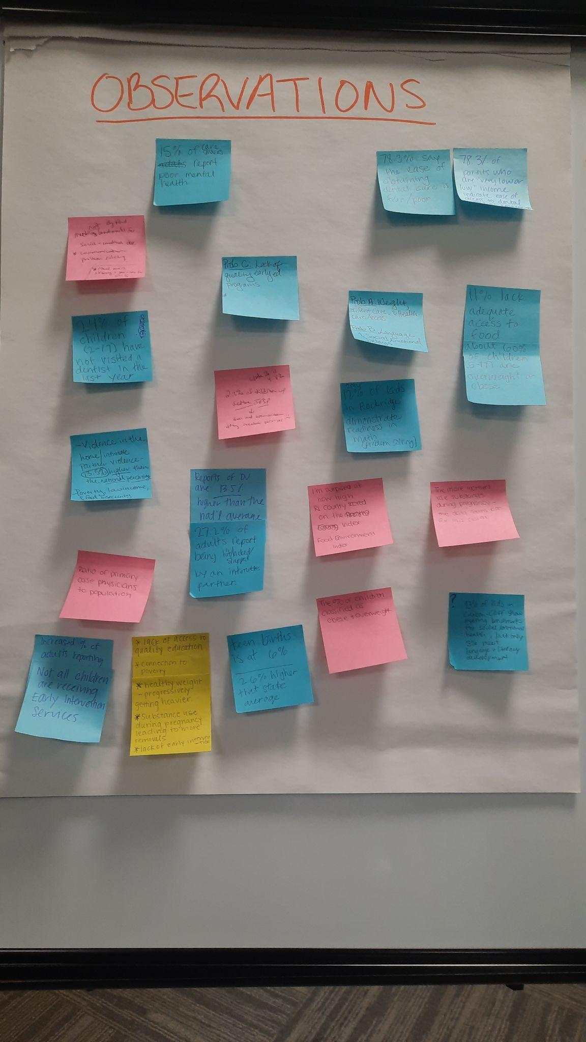
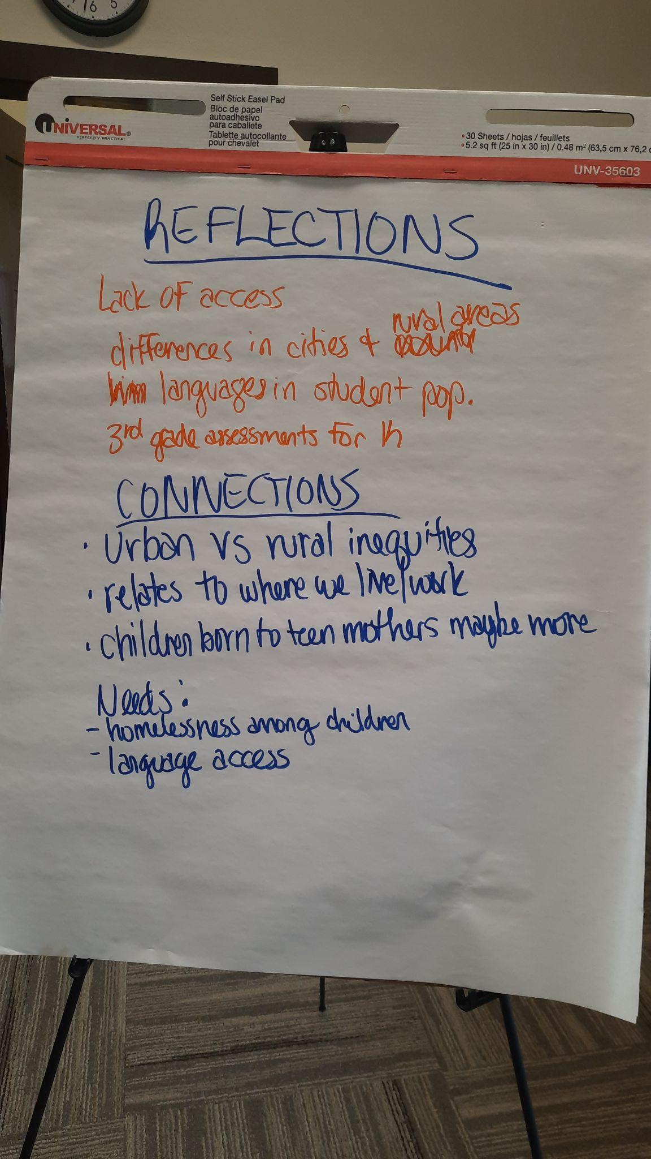

Review of Material
  - Phase 1: Assess Child & Family Outcomes
    - What: collect, assess, and prioritize child and family outcomes
      - Informed by AOK Networks’ Developmental Pathway
    - End result: agreed upon targeted problem: a subset of related child and family outcomes the Network will focus on for the next five-year cycle
  - CAPAP Process
    - Phase 1: Assess Child & Family Outcomes (July 2023 – February 2024)
      - Assess and prioritize child and family outcomes that are not being achieved
    - Phase 2: Assess the Early Childhood System (February – December 2024)
      - Assess and prioritize system assets/issues helping/hindering system’s ability to address problems in the TPF
    - Phase 3: Design Strategies for System Improvements (April-June 2024, January-March 2025, then annually)
      - Design strategies for prioritized system issues and assets to build upon; create the conditions for effective implementation
    - Phase 4: Implement, Track, Learn & Adapt, Scale (July 2025-June 2030)
      - Implement strategies & track small wins; Engage in continuous learning and adaptive action; scale
- Mentimeter Word Cloud: What’s one word for how you feel after today’s data conversation?

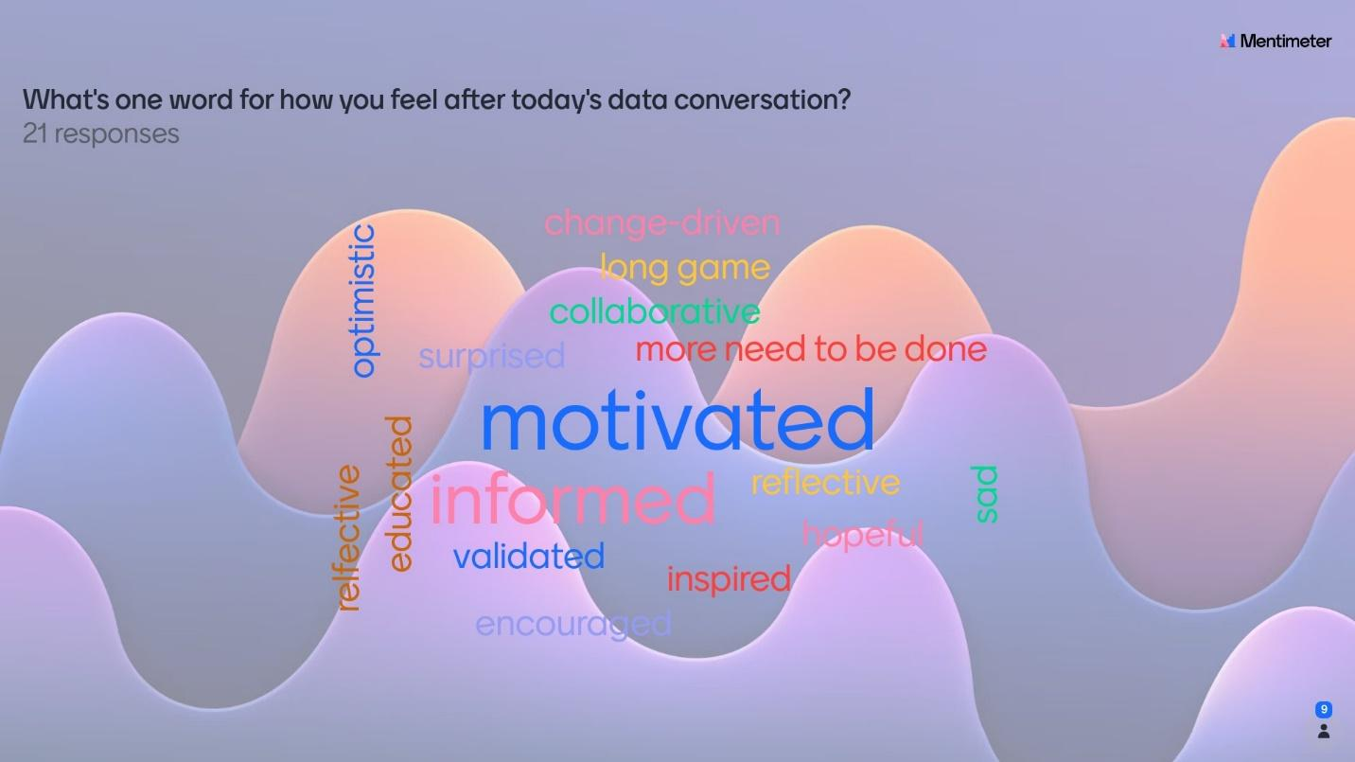

- Partner Update:
  - University of Illinois Extension is Hiring!
    - Community Outreach Worker, SNAP-Ed, Milan, IL
    - Apply @ go.illinois.edu/SNAPCW

Next Meeting:
December 4th, 2023
Butterworth Education Center
701 12th Ave, Moline, IL

