Communities build what they dream. Families get what they need. Children thrive.

AOK Network Meeting Notes:

- Introductions/Check-In: Do you prefer the ocean, desert, mountains, or forest?
- System Actor Map:
  - What is it?
    - An actor map offers a visual depiction of the key people and settings that make up and/or influence a system, as well as their relationships to each other.
  - Why create it?
    - To better understand current system actor roles and settings that relate to the Targeted Problem
    - To understand which roles and settings have greater influence on children and families experiencing the Targeted Problem
    - To understand where system actor connections are strong and weak
    - To identify opportunities to enhance and/or improve system connections
    - To identify who might be recruited to the Network and IRIS
- Centering Families in System Actor Map
  - Children and families experiencing our Targeted Problem are at the center of the system actor map. They are the most important actors within our system. Their strengths, assets, aspirations, connections, and relationships are key to creating a strong, sustainable systems and communities.
- Targeted Problem
  - Proximity
    - Determine the proximity of each system actor (1 – being closest to 4 – being furthest) in the amount of influence they have to those children and families experiencing the Targeted Problem
  - Name System Actors
    - Name specific people, places, and/or organizations in Rock Island County
- Large Group Debrief
  - What are you noticing about our system actor map? What stands out?
    - It was easier to put a proximity to a professional role versus a setting
    - One group put context to the proximity numbering system: 1 being they work with children and families 8+ hours a day, 2 - 8+ hours a week, 3 – 8+ hours a month, 4 – 8+ hours a year
    - It’s also important to remember that eventually all systems will be cross-sectoral
  - Any surprises? What are your concerns?
    - Concern – There are diverse needs for what we are asking, where different systems are coming together for one conjoined goal and it’s a lot of moving pieces to try to make it work (Example that was given: Having a head nurse spokesperson for all the nurses)
  - Which system actors are trusted by the community?
    - It’s important to put trusted in quotations – “trusted” because everyone may go to services that are well known and are at the table, but that doesn’t necessarily mean they are trusted by families and the community
    - It’s hard to trust systems and the services they have in place because they often fail families and communities
    - Trust is a two-way street between both those in the professional role as well as the families themselves
  - Who has the most influence on children and families experiencing the Targeted Problem?
    - Individuals in a professional role that have similar lived experiences and appearances to the families they are working with
    - The most influence comes from meaningful relationships with families
    - School social workers
    - Teachers
    - School Health Link (or any other school personnel)
    - Home visitors/advocates
    - Anyone in a professional role who has the direct assistance connection to families
    - It’s important if you’re in a professional role, to offer tangible options to families and have honest conversations with families, especially if you are not able to provide them everything they might need or are looking for
    - Families are most influenced and close to professionals who not only live in the community they are working for, but also are a part of the community through volunteering or other ways of involvement.
    - It’s important to remember that in order to have influence with children and families, you first have to be trusted

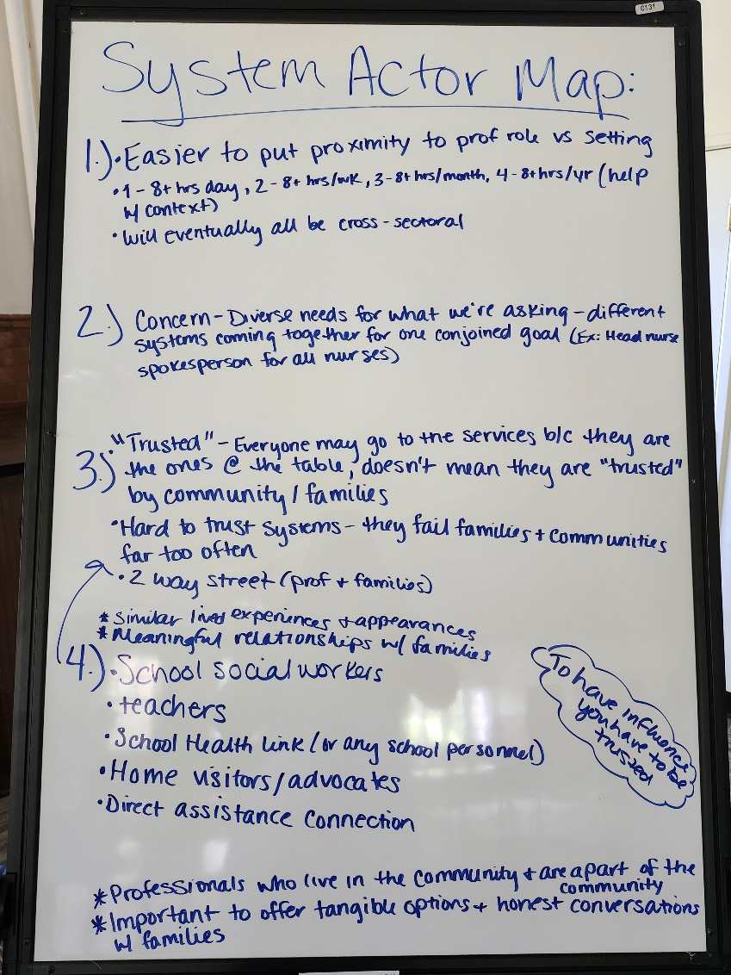

- Partner Presentation: Emily Cummings - Birth to Five Illinois
  - Mental & Behavioral Health Dissemination
    - Why are we here today?
      - Birth to Five Illinois
      - Family and Action Council Action Plans
      - Early Childhood Mental & Behavioral Health Needs Assessment Overview
      - Community Input & Feedback
    - Early Childhood Mental & Behavioral Health Regional Needs Assessment
      - Demographics
      - Local Community Collabs
      - ECEC programs
      - Slot gap
      - ECEC workforce
      - Parent/family/caregiver voice
      - Regional strengths & needs
      - Recommendations
    - Action plans
      - Optimize the ECEC workforce
      - Streamline service coordination
      - Improve affordability and access to specialized care
    - Optimize the ECEC workforce
      - Launch a community recognition award program for Early Childhood teachers, aiming to recognize six outstanding teachers by the end of December 2024
    - Streamline service coordination
      - Streamline service coordination by re-engaging at least 15 organizations in the IRIS platform by the end of 2024 – working closely with AOK and QCON on this
    - Improve affordability and access to specialized care
      - By the end of 2024, implement a universal screening tool in conjunction with the IRIS platform within five medical provider sites, including pediatric and family health centers, to help families access available support to meet their basic needs
  - Mental & Behavioral Health Findings
    - Data-Informed Decision Making
      - Found that ¼ adults report currently receiving mental health treatment, up from 17.6% in 2018
      - 25.3% of children in the QC are receiving mental health treatment, up from 12.7% in 2018
    - Recommendations
      - Workforce & education
      - Access & supports
      - Policy
    - Workforce & education
      - Mental health providers being educated on culturally representative care & incentivizing scholarships
      - Strengthen ECEC workforce with initiatives for mental health training accessibility, streamlined screening processes, and ending unsupported mandates
      - Promote whole-child approach and trauma-informed care while also tackling stigma and ensuring equitable mental health funding and subsidies
    - Access & supports
      - Having parent education on mental health, circle of security programs, and parent support/advocacy networks
      - Expand access to services through community-based counseling with translation services and flexible scheduling options – it’s rare to find a mental health service that’s open past 5pm and if you work full time, this is difficult to access
      - Integrate ECMHC (early childhood mental health consultants) in ECEC settings and have supports for both providers and children
  - For more information, view Birth to Five Illinois’ Regional Needs Assessment with a focus on Mental and Behavioral Health

Next Meeting:
August 7th, 2024
Butterworth Center – Oak Room (Basement)
1105 8th St, Moline, IL 61265

